S-Man: A Collaborative Student Project Management and Task Tracking System for the

College of Computer Studies at Our Lady of Fatima University, Valenzuela Campus

Marshalle Nopi B. Soriano ^{1,2,4}, Ivy B. Bumagat^{1,2,4} , Shaina Mae C. Prestoza^{1,2,4}

Mary Joyce R. Del Mundo,^{1,2,4,5}, Ricardo B. San Agustin^{1,2,4,6}

¹Information Technology

²College of Computers Studies,

³Research, Development and Innovation Center,

⁴Our Lady of Fatima University.

⁵Research Adviser

⁶Technical Adviser

October 2025

Endorsement

This project is dedicated to SMAN: A Collaborative Student Project Management and Task Tracking System for the College of Computer Studies at Our Lady of Fatima University, Valenzuela Campus, created to help students work better together, stay organized, and track their tasks more efficiently. We are truly grateful to God for giving us the strength, guidance, and perseverance to complete this project. We also thank the professionals, faculty, and mentors who generously shared their knowledge and advice. Special thanks go to our Technical Advisor and Research Advisor for their guidance, feedback, and encouragement, which were crucial in bringing this project to life.
Finally, we appreciate our friends and colleagues for their support, motivation, and teamwork throughout the process. Their help made the long hours of planning, coding, and testing much easier and more enjoyable.

Certificate of Originality

This project is dedicated to SMAN: A Collaborative Student Project Management and Task Tracking System for the College of Computer Studies at Our Lady of Fatima University, Valenzuela Campus, created to help students work better together, stay organized, and track their tasks more efficiently. We are truly grateful to God for giving us the strength, guidance, and perseverance to complete this project. We also thank the professionals, faculty, and mentors who generously shared their knowledge and advice. Special thanks go to our Technical Advisor and Research Advisor for their guidance, feedback, and encouragement, which were crucial in bringing this project to life.
Finally, we appreciate our friends and colleagues for their support, motivation, and teamwork throughout the process. Their help made the long hours of planning, coding, and testing much easier and more enjoyable.

Acknowledgement

This project is dedicated to SMAN: A Collaborative Student Project Management and Task Tracking System for the College of Computer Studies at Our Lady of Fatima University, Valenzuela Campus, created to help students work better together, stay organized, and track their tasks more efficiently. We are truly grateful to God for giving us the strength, guidance, and perseverance to complete this project. We also thank the professionals, faculty, and mentors who generously shared their knowledge and advice. Special thanks go to our Technical Advisor and Research Advisor for their guidance, feedback, and encouragement, which were crucial in bringing this project to life.
Finally, we appreciate our friends and colleagues for their support, motivation, and teamwork throughout the process. Their help made the long hours of planning, coding, and testing much easier and more enjoyable.

Dedication

This project is dedicated to SMAN: A Collaborative Student Project Management and Task Tracking System for the College of Computer Studies at Our Lady of Fatima University, Valenzuela Campus, created to help students work better together, stay organized, and track their tasks more efficiently. We are truly grateful to God for giving us the strength, guidance, and perseverance to complete this project. We also thank the professionals, faculty, and mentors who generously shared their knowledge and advice. Special thanks go to our Technical Advisor and Research Advisor for their guidance, feedback, and encouragement, which were crucial in bringing this project to life.
Finally, we appreciate our friends and colleagues for their support, motivation, and teamwork throughout the process. Their help made the long hours of planning, coding, and testing much easier and more enjoyable.

Marshalle Nopi B. Soriano
Ivy B. Bumagat
Shaina Mae C. Prestoza
Researchers

Executive Summary

This project is dedicated to SMAN: A Collaborative Student Project Management and Task Tracking System for the College of Computer Studies at Our Lady of Fatima University, Valenzuela Campus, created to help students work better together, stay organized, and track their tasks more efficiently. We are truly grateful to God for giving us the strength, guidance, and perseverance to complete this project. We also thank the professionals, faculty, and mentors who generously shared their knowledge and advice. Special thanks go to our Technical Advisor and Research Advisor for their guidance, feedback, and encouragement, which were crucial in bringing this project to life.
Finally, we appreciate our friends and colleagues for their support, motivation, and teamwork throughout the process. Their help made the long hours of planning, coding, and testing much easier and more enjoyable.

Table of Contents
Title page | i
Endorsement | ii
Certificate Of Originality | iii
Acknowledgement | iv
Dedication | v
Executive Summary | vi
Table of Contents | vii
List of Figures | ix
List of Tables | x
List of Appendices | xi
1.0 Introduction | 1
1.1 Background of the Study | 2
1.2 Objectives of the Study | 2
1.2.1 General Objective | 2
1.2.2 Specific Objectives | 4
2.0 Review of Related Literature and Studies | 4
2.1 Related Literature | 4
2.1.1 Local Literature  2 | 4
2.1.2 Foreign Literature | 5
2.2 Related Studies | 7
2.2.1 Local Studies | 7
2.2.2 Foreign Studies | 9
3.0 Research Design and Methodology | 12
3.1 Conceptual Framework (IPO Model) | 12
3.2 System Development | 13
3.2.1 Agile Development Phase | 14
3.3 System Diagram | 14
3.4 System Flow Chart. | 16
3.3 System Diagram | 17
3.4 System Flow Chart. | 18
3.5 Testing and Evaluation. | 18
3.5.1 Respondents | 18
3.5.2 Research Design | 19
3.5.3 Sampling and Population | 19
3.5.5 Data Gathering Procedure | 19
3.5.6 Ethical Consideration | 20
3.5.7 Research Instrument. | 21
3.5.8 Testing Procedure | 24
3.6 Evaluation Procedure | 24
BIBLIOGRAPHY
APPENDICES

RESEARCHER’S PROFILE

List of Figures
Figure No. | Description | Page
Figure 1 | Input-Process-Output (IPO) Model of S-Man | 15
Figure 2 | System Architecture | 19
Figure 3 | Diagram - 0 of S-Man | 20
Figure 4 | Entity-Relationship Diagram of S-Man | 20
Figure 5 | Use-Case Diagram | 21
Figure 6 | Flowchart of S-Man | 22
Figure 7 | S-Man’s Wireframe | 23
Figure 8 | SDLC Waterfall Model | 25
Figure 9 | Software Product Quality (ISO 25010) | 28

List of Tables
Table No. | Description | Page
Table 1 | Input-Process-Output (IPO) Model of S-Man | 15
Table 2 | System Architecture | 19
Table 3 | Diagram - 0 of S-Man | 20
Table 4 | Entity-Relationship Diagram of S-Man | 20

List of Appendices
Appendix No. | Description | Page
Appendix A | Work Breakdown Structure (WBS) | 15
Appendix B | Gantt Chart | 19
Appendix C | Budgetary Allowance | 20

- Introduction

In academic settings, it is an essential part of college education to socialize and communicate with your peers, no matter the course one is enrolled in, communication and socializing are integral parts and requirements of each one. One of the ways that this is developed and improved in students is through group works and shared activities. Within these group tasks, there are assigned team leaders and team members. It is through this that students are taught the significance of roles and the responsibilities that come with them. What follows after is entirely dependent on factors such as communication and participation. Establishing good communication is the foundation of every productive group. It is through it that information is distributed, tasks are assigned, and consequences are brought up. Without good communication, productivity may be affected. For example, an empirical investigation by Morgan et al. (2021) focused on team communication behaviors and found that teams that engaged in open and continuous communication experienced much higher levels of productivity and satisfaction. Participation, on the other hand, is something that is difficult to promise. For instance, a member of the group may choose to not participate for many reasons, which may possibly impact and influence other members' productivity as well. In order to ensure participation, one may resort to sanctions or punishments. A study by Chapkovski (2021) studied the influence of collective punishment or sanctions on an entire group when cooperation within said group falls below a certain level. Their findings showed that collective punishment does indeed lead to higher cooperation compared to scenarios where no punishment is applied. With this in mind, group activities and tasks appear to be quite more complicated than they seem. This is where S-Man: A Collaborative Student Project Management and Task Tracking System enters into the conversation. This particular system enables those assigned with the role of leading a team in group activities, the ability to efficiently communicate with their group members, assign specific roles and tasks to them, set appropriate deadlines for said tasks and also decide consequences for not participating. It also includes features such as task feedback and task overview, allowing not only the leaders but also the members to communicate with each other regarding certain tasks, even if it was assigned to a different member, further improving work productivity and quality. S-Man is also able to facilitate educator needs, such as grade assignment, task creation and role delegation. S-Man is set to change the way students approach group activities, it will allow them to see a new perspective on group work, where the importance is now not only limited to the output of the group, but also how the members participate, communicate and overcome problems together.

  - Objective of the Study

This study aims to develop and implement S-Man, a collaborative student project management and task tracking system specifically designed for the College of Computer Studies at Our Lady of Fatima University, Valenzuela Campus. The system seeks to improve project participation, task assignment, and accountability among students by providing real-time progress tracking and transparent grading. S-Man intends to create a system that establishes efficient communication between students, group leaders, and also professors. In order to ensure that tasks are completed on time and contributions of each member are evaluated and graded fairly, the system will implement features such as an automated task tracker, setting of deadlines for specific tasks, a task contribution and performance overview, and member feedback. It aims to improve group productivity, promote fair grade distribution based on output, and support professors in grading.

1.1.1 General Objective

The general objective of this study is to design and develop a project management tool for the College of Computer Studies students of Our Lady of Fatima University, Valenzuela Campus, tailored for academic tasks, named S-Man, that enables students, specifically team leaders and team members, to have a dedicated system to use in group tasks that will allow them to communicate effectively with each other, assign tasks, and provide feedback to each other.

1.1.2 Specific Objectives

The specific objective of the study aims:
- To design a separate yet interconnected interactive dashboard using Node and React for students, group leaders, and professors that contains an overview of the students’ enrolled classes, assigned tasks, deadlines, and recent feedback. As well as for professors to view recently created tasks, recent submissions, grade sheets, and enrolled classes.
- To create a task monitoring system using Firebase Firestore that allows group leaders to delegate, delete, and revise tasks while allowing professors to oversee individual contributions and finalize grades.
- To implement an automated reporting feature using JavaScript and Firebase that generates individual and group contribution summaries, highlighting inactive members and incomplete tasks.
- To integrate a real-time notification system using Firebase Cloud Messaging that alerts users about deadlines, task updates, and grading decisions via web notifications.
- To secure a role-based access control using Firebase Authentication, allowing students, leaders, and professors to interact within their designated permissions while still maintaining system integrity.

  - Scope and Limitation

The scope of this study is defined by the features and functionalities of S-Man, a system designed to enhance group communication, participation, and transparency in academic tasks. Its primary goal is to ensure fair grading and equal evaluation of student contributions by providing an organized platform for task assignment, monitoring, and feedback.

Scope

The study focuses on developing a web-based project management tool system dedicated for academic group tasks. The system will be able to provide a platform for students and professors alike to upload, create, assign, and grade tasks. Using HTML, CSS, JavaScript and Firebase. Three separate dashboards will be created for students and professors. Each dashboard will contain different information relevant to their role. For group members, information such as classes enrolled, assigned tasks, recent feedback, calendar, and grades will be available in the dashboard. For group leaders, the same information will be present, in addition to leader tools such as setting tasks, setting deadlines, and making decisions. For professors, a grade sheet, enrolled classes, group assignments, and decision overrule will be present in their dashboard. S-Man will also enable professors to create classes through the professor dashboard. It is capable of accommodating specific types of group tasks such as PowerPoint presentations, Video and Audio recordings, and written tasks. S-Man will also be able to send notifications via web notifications to alert students of recent changes made, whether it be from professors assigning new tasks or members being assigned new deadlines. A report and an overview of the whole team's contribution will be generated by S-Man at the end of every assigned task, showing members who participated and did not. This report will be accessible to the whole team as well as the professor. The system will also include a decision process where the assigned group leader has the ability to decide whether or not to include a particular member in the grade they will receive as a group. The professor will also have the capability to overrule this decision if they choose to do so. S-Man will also include a feedback feature for both task creation and deadline assignment, where members can request a deadline change. The system's authentication will be handled by Firebase.

Limitation

S-Man like other systems, has its own set of limitations. The system requires an internet connection to function, as it relies on Firebase for real-time updates and data storage. A mobile application will not be developed, as S-Man will only be accessible through web browsers. The task assignment process is manual. It will not have any kind or form of offline functionality. Additionally, browser dependency may affect performance, as the system’s responsiveness can vary depending on the user’s device. The system will also not be able to provide the full features of project management tool websites, as it was specifically designed to handle only academic-related tasks. S-Man aims to improve group project efficiency, it does not replace face-to-face collaboration but rather enhances it by providing structured task management and tracking tools.

  - Significance of the Study

The development and implementation of S-Man: A Collaborative Student Project Management and Task Tracking System offer significant benefits to various beneficiaries within the College of Computer Studies at Our Lady of Fatima University, Valenzuela Campus. This system aims to enhance academic collaboration, improve task management, and ensure transparency in project-based learning, making it a valuable tool for students, group leaders, and professors.

To the Students

The system provides an accessible and efficient platform for tracking group-assigned tasks, deadlines, and progress. Additionally, it promotes fair grading of tasks based on output. S-Man holds students accountable for their actions and encourages them to be responsible members.
To the Group Leaders
S-Man allows group leaders to efficiently assign tasks, monitor task progress, and review submissions, ensuring that every group member's activity is monitored. They will also be able to decide whether to include certain group members based on their output and performance, making grading more transparent and objective.

To the Professors

Professors can use S-Man to monitor student participation in groups and assign grades fairly based on member output. They can also respond to questions about specific tasks in designated classes instead of manually figuring out where the student is enrolled, in what year, and in what subject.

To the Future Researchers

Future researchers can use the data gathered from S-Man to analyze areas of improvement, assess the effectiveness of the system’s application in academia, and explore potential enhancements to optimize its functionality and impact on collaborative learning.

2.0 Review of Related Literatures and Studies

Countless other software solutions in the market today offer task management and collaboration features, but most of these are built with workplace teams in mind rather than academic use. S-Man focuses on student group work, ensuring accountability and structured delegation for academic projects. Research and Literature about collaboration, task tracking, and academic management provides valuable insights that support the development of S-Man, helping shape its features and functionality to better aid its beneficiaries, the students and professors.

2.1 Related Literature

Published literature that is not only about collaboration, communication, and group participation but also the effectiveness of existing project management software tools offers perspective and insight into the strengths and weaknesses of such systems, providing a solid foundation of understanding that can help S-Man be designed more effectively and efficiently for academic use. These findings allow S-Man to be developed with features that directly address the needs of students, whether they are assigned leaders or just group members.

2.1.1 Local Literature

Collaborative learning, such as group activities and projects, usually requires effective communication and cooperation between students. In the modern era, where the choice of holding classes synchronously is an option, group cohesion and teamwork play an important role in making progress in collaborative tasks. Dulinayan et al. (2023) discuss the relationship of group cohesion and teamwork between college students when it comes to online learning, emphasizing the significance of effective collaboration in virtual settings. Factors such as communication, mutual support, as well as shared goals, according to the authors, were essential when it comes to creating a productive team environment. S-Man reinforces these principles by equipping student leaders with tools to assign tasks, monitor deadlines, and coordinate feedback, building a digitally cohesive team environment. In the academic field, grades play an important role not only in the formation of the future of a student, but also in the experiences and relationships a student will form throughout his journey. Collaborative learning, such as group activities and projects, requires communication as well as cooperation between students. Abance, Gabrillo, and Quinto (2023) explore the importance of Online Collaborative Learning (OCL) when it comes to thesis writing, specifically focusing on the experiences of undergraduate students. Their article puts weight on the role of collaboration, specifically in the context of thesis writing, where students benefit from shared responsibility as well as flexible communication, despite the challenges that may occasionally exist such as vague instructions and the differing levels of participation. By offering request-based deadline changes and visible task progress, S-Man promotes adaptive collaboration for more equitable workloads.
S-Man is a tool accessible via the internet, and its accessibility is a key feature when it comes to promoting collaborative learning. The usage of blended learning models further enhances this experience. Villanueva, Redmond, Galligan, and Eacersall (2022) in their article wrote about the role of blended learning in the Philippine K-12 schools, putting importance on effective interactions and its effect on building learning communities. The article highlights the relevance of integrating technology as well as social media in order to create dynamic learning environments where students can collaborate more effectively. S-Man aligns with this by delivering a real-time, web-based platform where students can engage with academic tasks collaboratively, regardless of physical presence. Insights such as this support the existence of platforms such as S-Man. Viado and Espiritu (2023) explored the impact of collaborative-individual learning on secondary students in the Philippines. Their article emphasizes the significance of integrating collaborative learning approaches into teaching, specifically in enhancing critical thinking skills in students. In the same vein, S-Man fosters critical thinking by allowing transparent peer evaluation and accountability for each contribution. Additionally, Gonzales et al. (2021) examined the influence of online collaborative learning platforms on students’ attitudes, achievements, and experiences in terms of science education. Students were generally satisfied with collaborative learning platforms, but challenges such as lack of communication and unequal participation seemed to be the main obstacles in the collaborative process. This is exactly what S-Man is built to address, by giving leaders visibility over member tasks and allowing consequence-based inclusion or exclusion in group grades.

2.1.2 Foreign Literature

The integration and application of technology into education, especially in online learning environments, have proven to be important when it comes to promoting critical thinking. According to an article written by Garrison, Anderson, and Archer (2009), with the right teaching and social presence, cognitive presence, which they focused on in the article, can be effectively supported, leading to meaningful discourse and collaboration within virtual settings. The article stresses the importance of creating environments where participation and communication are important factors that contribute to success and progress in group tasks. S-Man provides that environment by integrating leader-moderated task discussion and professor oversight to nurture engaged, thoughtful collaboration. Similarly, Butler (2025) gives prominence to the significance of alternative grading systems, such as standards-based grading as well as “ungrading”. These kinds of systems help emphasize transparency, flexibility as well as reduced stress among educators as well as students, in alignment with the notion that creating supportive environments improves student collaboration as well as participation. S-Man complements this shift by ensuring that students’ contributions are logged and summarized, reducing ambiguity and encouraging honest performance. An article by Sanders (2021) investigates the influence of removing traditional grading practices in favor of self-reflection-based assessment. According to his article, traditional grading methods can possibly hinder learning and student motivation, whereas feedback-driven approaches, on the other hand, enhance engagement and promote participation. S-Man meets this need by letting members receive feedback from leaders and professors on task quality, encouraging constructive learning cycles. In line with this, another article, this time written by Bronke (2023), explores the change from traditional grading to standards-based grading (SBG), as well as the support that educators will need in order to implement it effectively. The article highlights how professional development improves educators' confidence in adopting SBG, emphasizing transparency and, more importantly, performance-based assessment, strengthening the idea that structured systems promoting accountability and fair evaluation can improve group participation and collaboration. With its structured evaluation dashboard, S-Man simplifies grading for professors while also helping students understand performance metrics. Lastly, Fagbohun et al. (2024) explore the role of Large Language Models (LLMs) in grading, emphasizing their capability to promote fairness, efficiency, and also transparency when it comes to student assessments. Their journal shows how it is possible for automated grading systems and adaptive testing platforms to improve evaluation accuracy while at the same time addressing biases and data privacy concerns. This aligns with the principles of S-Man as a structured system whose one of its purposes is to promote accountability, fair and transparent evaluation, and improve group participation.

2.2 Related Studies

Studies, both foreign and local, provide valuable insights into assessment, accountability, and the role of structured systems in improving group participation. Existing previous studies on grading methods, automated evaluation tools, as well as collaborative learning frameworks provide important knowledge on how structured approaches impact student participation and performance as a whole. These studies help in understanding how incorporating accountability measures can help enhance fairness and transparency in academic settings.

2.2.1 Local Studies

Academic activities that require cooperation and communication with other students usually encourage communication, engagement, and social interaction. In the Philippines, activities such as group work are considered a tried-and-tested effective strategy for improving student collaboration and performance. Deysolong (2023) emphasizes that such kinds of activities, specifically cooperative learning, enhance students' critical thinking and social skills and also promote active engagement. The study emphasizes the fact that through working as a group, students are able to engage more in meaningful discussions, which leads to a deeper understanding of the activities. It also encourages inclusivity and respect for varying perspectives among students, which is important in academic settings. S-Man supports this by assigning clear roles and responsibilities, ensuring each group member actively contributes to meaningful discussions. The advantages of effective cooperative learning don’t stop there. A study written by Fragata and Limpot (2023) emphasizes the role of cooperative learning in reducing the negative effects of peer pressure on student motivation. The study found that while peer pressure can reduce a particular student's passion for learning, group activities and discussions, as well as collaborative problem-solving, have helped correct said effects. The encouraging environment that collaborative learning creates influences students to stay engaged and motivated, further solidifying the importance of collaborative learning in education. S-Man builds this motivation loop by letting peers see each other’s progress, which inspires lagging members to catch up and stay involved.
Collaborative learning isn't only limited to improving the social and communication skills of students, but it also plays an important role in addressing challenges that hinder comprehension and engagement in academic subjects. Rogayan, Rafanan, and De Guzman (2021) identified various obstacles faced by STEM students, including difficulties in understanding complex topics and low confidence when working independently. While the study did not focus solely on group work, it emphasized the importance of supportive learning environments that help students overcome academic anxieties. S-Man contributes to this by offering a structured collaborative platform where students can view task status, communicate with peers, and request feedback—reducing confusion and fostering a more confident, participative learning experience. Aside from subjects, collaborative learning has also been shown to be beneficial when it comes to learning new languages. Tolentino and Aggabao (2020) found that the effectiveness of integrating collaborative instructional strategies into second-language learning was evident. Their study found that students who were exposed to said strategies showed improvements, albeit slight, in terms of their learning performance compared to the traditional setup. Adding to that, both groups, those who were and weren't exposed, showed the same attitude when it came to collaborative learning, further proving that group-based strategies can help students better understand a second language. S-Man offers structure for such strategies, ensuring that language tasks are distributed evenly and that contributions can be reviewed transparently. Additionally, a study conducted by Dugang (2020) investigated school teamwork and effectiveness itself, revealing that efforts of collaboration within schools do indeed play an important role in creating an effective learning environment, although the study also found that it was lower in areas of problem-solving and team processes. This further supports the importance of creating group-based strategies in improving both collaboration and learning outcomes in academic settings. S-Man improves this by making problems traceable to specific users or tasks, giving groups the information needed to solve issues collaboratively and efficiently.

2.2.2 Foreign Studies

Collaborative learning isn’t just limited to the classroom, as it can also be done virtually. In a study conducted by Liu, Yang, and Chao (2019) analyzed how elementary students participated in a two-year digital storytelling community through a social network application. The study's findings showed that student participation in long-term virtual collaboration contributed to the development and improvement of oral reading proficiency, motivation, and engagement, particularly when students worked as a team. S-Man sustains long-term digital collaboration by offering persistent dashboards that record historical activity and enable continued group alignment. Similarly, Muluye and Tadesse (2020) investigated the difficulties that impede student participation when it comes to project work. The study also identified factors such as lack of interest, time constraints, unclear individual responsibilities, and also ineffective assessment methods. The conducted study introduced interventions and other things which significantly improved student participation. These findings reinforce the idea that structured systems do in fact promote accountability. S-Man directly tackles these with role-based access, visible contribution summaries, and leader-managed assessments to drive clarity and fairness. Xu, Stephens, and Lee (2024) explored student engagement in collaborative learning by validating and developing a Chinese CL engagement scale. Their study managed to identify three particular key dimensions of engagement, particularly cognitive, behavioral, and emotional. Their findings demonstrated that structured system assessment methods help students understand the activities more, leading to an increase in student participation in group activities. S-Man addresses all three, cognitive via structured tasks, behavioral via tracking tools, and emotional via real-time peer interaction.
Focusing on learning, Terenzini et al. (2013) found that collaborative learning methods significantly improved problem-solving, group participation, and communication skills compared to traditional lecture-based methods in undergraduate engineering courses. The findings of their study showed that collaborative learning led to significantly bigger improvements in the aforementioned areas. These said advantages remained even after accounting for the students' prior knowledge, further solidifying the effectiveness of structured and interactive learning methods in improving student performance and engagement. This supports S-Man’s mission to shift from static teamwork to dynamic group interaction, using real-time dashboards and progress visibility. Lastly, Carr et al. (2024) studied the impact of assigned group work in an asynchronous online physiology lab course and found out that students in groups reported a much higher sense of belonging than those who didn't. Their findings emphasize that peer interactions that are structured within online learning environments improve student participation, motivation, and engagement, further reinforcing the benefits of collaborative learning in improving student performance and engagement. S-Man reinforces this sense of inclusion by showing every member how they contribute to the group’s success and ensuring no work goes unnoticed.

3.0 Research Design and Methodology

The Research Design and Methodology section of this paper details the procedures, processes, and tools that will be used to create and evaluate the website system that is S-Man. This section will define and provide the framework for creating and assessing the website system, beginning with the conceptual framework that outlines the input-process-output (IPO) model of the software. It is then followed by the quantitative research procedure, which includes vital components of the study, such as the research design to be utilized, the sampling and population focus, and the research locale where data gathering will take place. The ethical considerations of the study are also covered in this section, detailing the steps the proponents will take to protect the rights, privacy, and well-being of stakeholders, specifically the College of Computer Studies students at OLFU Valenzuela Campus.

3.1. Conceptual Framework

The conceptual framework of S-Man is based on the Input-Process-Output (IPO) model, which illustrates the system's workflow from user interactions to final output.

FIGURE 1 Conceptual Framework of S-Man
The figure 1.0 depicts the conceptual framework of S-Man, illustrating its core components and their interconnectedness. It provides an overview of the entire process that S-Man follows from start to finish.

3.2 Quantitative Research Procedure

This section outlines the research methods used to assess the system’s effectiveness through quantitative analysis. It details the selection of respondents, research design, sampling techniques, and research locale. Additionally, it describes the procedures for data collection, ethical considerations, and the research instruments used to gather and analyze data.

3.2.1 Respondents

The respondents of the study will be students from the College of Computer Studies at Our Lady of Fatima University – Valenzuela Campus, particularly those under the College of Computer Studies, specifically Computer Science and Information Technology. The study will recruit fifty (50) respondents from the College of Computer Studies (CCS) at Our Lady of Fatima University, Valenzuela Campus. These participants must be currently enrolled CCS students. Unenrolled CCS students will not be included in the study. To ensure the validity and objectivity of the data, the researchers used a probability sampling method, specifically the simple random sampling technique. This approach ensures that every student in the population has an equal and independent chance of being selected, minimizing bias and enhancing the generalizability of the results.

3.2.2 Research Design

This study will employ a quantitative descriptive research design to evaluate S-Man. The descriptive design will be used to systematically gather and analyze data from target users to identify trends, perceptions, and levels of usability and effectiveness of the system. The research aims to enhance student project management by improving group collaboration through an effective system for task distribution, progress tracking, and communication support.

3.2.3 Sampling and Population

The target population for this study includes students from the Bachelor of Science in Information Technology (BSIT) and Bachelor of Science in Computer Science (BSCS) programs under the College of Computer Studies at Our Lady of Fatima University, Valenzuela Campus. These students regularly engage in group-based academic projects, making them appropriate for evaluating the S-Man system. A total of fifty (50) students will be selected using simple random sampling, a method that ensures every eligible participant has an equal chance of being chosen. This technique minimizes selection bias and helps ensure that the sample is representative of the larger student population. The selected participants will provide valuable insights into how the system can support collaboration, task tracking, and accountability in academic settings.

3.2.4 Research Locale

The researchers’ study will be conducted at Saint Benedict Hall at Our Lady of Fatima University – Valenzuela Campus, specifically within the College of Computer Studies department. This setting was chosen because it houses the primary respondents of the study being conducted. With the collected data from the participants, the researchers will be able to know and understand the effectiveness and impact of S-Man. Through this study, the researchers aim to measure the effectiveness of the system in enhancing academic group task management.

3.2.5 Data Gathering Procedure

The study will gather data surveys to evaluate the level of acceptability of the system. This survey will be through a link & paper survey, to the selected participants. The evaluation will also be conducted using a Likert Scale and ISO 25010-based evaluation form. Data collection and the overall study will be conducted from July 28 to September 29. Respondents will be involved in the study by completing surveys and evaluations within this period. Each participant is expected to spend approximately 5–15 minutes per survey, with participation occurring once during this timeframe. Once the target number of participants is reached, the researchers will begin to interpret and evaluate the data, ensuring that each one of the responses is addressed.

3.2.6 Ethical Consideration

The proponents will provide an informed consent form for participants, which includes their names and an information sheet detailing essential aspects of the study. This sheet will cover an Introduction, the Purpose of the Research, and Participant Selection, giving basic information about the form. It will also outline the Procedures, Duration, Risks, and Benefits, specifically focusing on users of S-Man. Confidentiality will be a top priority, ensuring that all collected data remains secure and is used solely for academic purposes. The results will contribute to research findings aimed at improving student task management and collaboration within academic settings. Participation is entirely voluntary, and willing respondents will receive a Letter of Consent. This ensures mutual agreement on the research process while maintaining strict confidentiality and privacy of participant information. All collected data will be stored in a private Google Drive folder secured by the principal investigator’s OLFU email account. Only the researchers will have access to this folder. The data will be used solely for academic purposes related to this study. After the research is completed and the final report is submitted, all data will be kept for six months and then permanently deleted from the drive to ensure privacy and data security.

3.2.7 Research Instrument

To assess the effectiveness of the S-MAN system, the researchers used two main tools: a Google Forms survey and a printed questionnaire. These were given to students, group leaders. To get feedback on how easy the system is to use, how well it helps with tracking tasks, and whether it supports fair grading. The surveys used close-ended and Likert-scale questions to understand how the system supports teamwork and accountability in academic projects. A final report will be submitted to the department and advisers. The collected data will be analyzed using descriptive statistical methods such as frequency counts, averages, and percentage distributions to summarize participant responses.

3.3 Software Design

This section presents the software design of S-Man, illustrating its system architecture and foundational components. It includes diagrams and descriptions that outline the system’s structure, interactions, and data flow, ensuring a clear understanding of its functionality. These design elements serve as a blueprint for the system’s development and implementation.

3.3.1 System Architecture

The figure below shows the system architecture of S-Man, providing an overview of its processes during user interaction. There are four main stakeholders who use the system, and the diagram depicts how various web pages and dashboards interact. It also shows how data is gathered, modified, and stored in the database with the support of a web server.
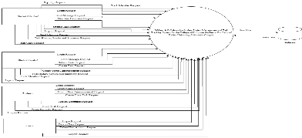

FIGURE 2.0: System Architecture

3.3.2 Diagram – 0

Diagram 0 presents the system’s user input mechanisms, maintaining the same four input categories established in the preceding diagram. Additionally, it visualizes the spectrum of user requests processed by the system.
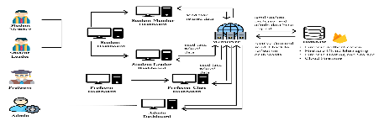

Figure 3 Diagram - 0 of S-Man

3.3.3 Entity-Relationship Diagram

The figure below shows how the database tables in S-Man are connected. Since S-Man is a complex system, these relationships help make sure data is stored and retrieved correctly when users need it. Many of these connections are one-to-many relationships.

Figure 4 Entity-Relationship Diagram of S-Man

3.3.4 Use-Case Diagram

The figure below shows the use case diagram for S-Man, covering student members, leaders, and professors. Some functions are shared between roles, such as submitting reports or viewing schedules, while other features are restricted to specific users. This structure allows efficient collaboration while maintaining proper access controls.

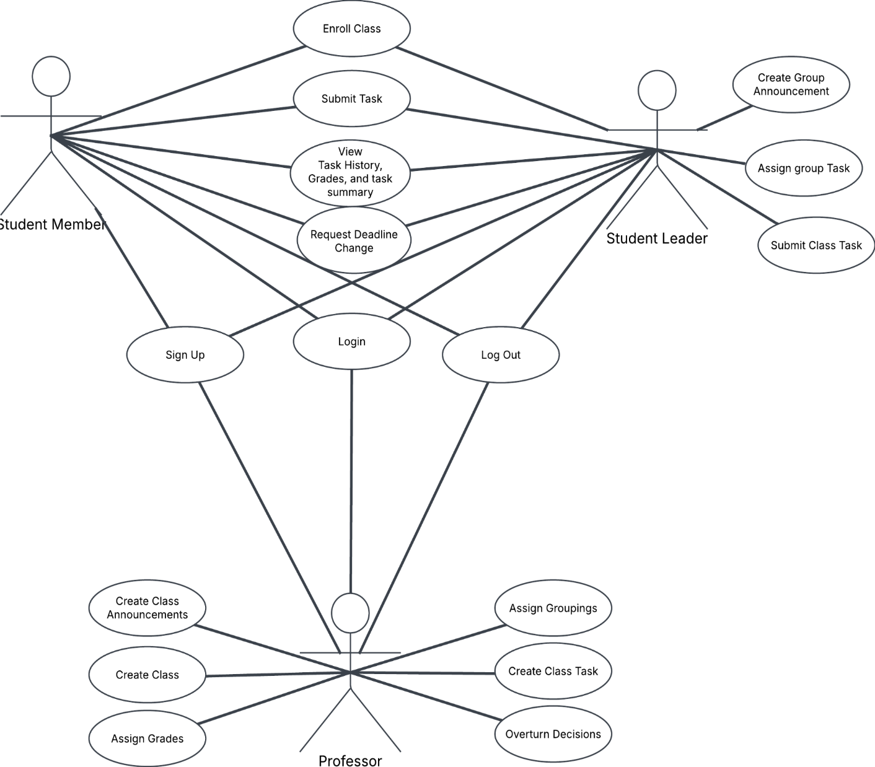
Figure 5 Use-Case Diagram

3.4 Programming Design Tools

The proponents decided to use flowcharts as the design tool because they clearly show how all the website's processes work together. Flowcharts help visualize the step-by-step flow of the system by visualizing what happens first, what comes next, and how different paths connect. They're simple enough for anybody to comprehend, but still contain enough detail for development.

3.4.1 Flowchart

The figure below shows the S-Man flowchart, which maps out the system’s decision-making process. For example, when a user logs in, the flowchart guides them through different paths based on specific criteria. If certain conditions aren’t met, the user is directed to an alternative workflow that resolves their access or permissions. This visual approach helps clarify how user inputs determine system responses at each step.

Figure 6 Flowchart of S-Man

3.5 Product Design

The researchers of this study utilized a wireframe approach for the website. The proponents chose wireframing because it effectively visualizes features and layouts, enabling a more structured and organized development process. This method helps prevent design chaos by establishing clear guidelines before implementation begins.

3.5.1 Wireframe

figure below displays the complete wireframe compilation of S-Man's webpages. This consolidated visualization demonstrates the interconnections between all interface components while maintaining design consistency across the system. The wireframe serves as a structural blueprint to validate navigation logic and interface element placement prior to development implementation.
Figure 7 S-Man’s Wireframe

3.6 Software Development

This section will focus on the structured approach used to plan, design, develop, test, and deploy software systems. Software development models are critical frameworks in system development, aimed at ensuring that the development process is organized, efficient, and capable of delivering high-quality software that meets the defined objectives and user needs. The researchers will use the waterfall model, since before subsequent steps occur, the current phase must be completed first. In this model, the researchers modified it and added verification or validation in the testing phase so any deviations can be corrected immediately before deployment in the production environment.
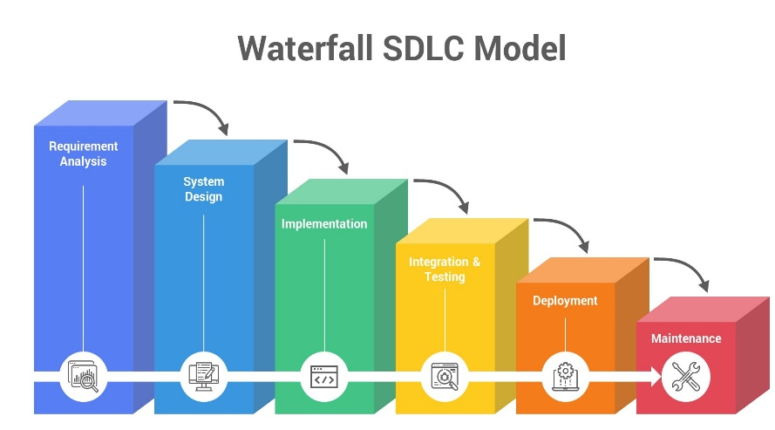
FIGURE 8.0: SDLC Waterfall Model

3.6.1 SDLC Approach (Waterfall Model)

The initial phase of the waterfall model is requirements gathering. In this phase, the researchers conduct interviews to determine system requirements, which include both processes and user stories. After obtaining both functional and non-functional requirements, the second phase - system design - is implemented. During this phase, the researchers develop visual representations of data, progressing from generalization to specification. This involves creating three key elements: database architecture, system diagrams, and solution architecture. Following successful conceptualization, the project moves to system implementation using available technologies through coding. Developers implement specific algorithms, verify code functionality, and perform initial unit testing. Once all components are developed, they proceed to the testing phase where defects are identified and comprehensive testing is conducted.
Finally, after successful validation of all components, integrations, and the complete system, the software becomes ready for deployment. The last ongoing aspect is maintenance, ensuring continued system performance and addressing any post-deployment issues.

3.7 Testing Procedure

This section will focus on the structured approach used to plan, design, develop, test, and deploy software systems. Software development models are critical frameworks in system development, aimed at ensuring that the development process is organized and efficient. The proponents chose beta testing as the primary testing method to evaluate the system’s performance in a real-world setting with actual users. This approach allows for the identification of bugs, usability concerns, and unexpected behaviors that may not surface during internal testing. Feedback gathered during beta testing is crucial for refining the system before its final release.

3.7.1 Beta Testing

Step 1: User Registration and Login
Test users including student group members, student group leaders, and professors must successfully register and log in to their accounts. The system verifies credentials and directs users to their respective dashboards, displaying clear error messages for incorrect login attempts and allowing retries.

Step 2: Project Creation and Management
Professors initiate academic group projects by entering project details and selecting participating groups. Student group leaders can then create group-specific tasks for their assigned members but cannot create class-wide tasks. Student group members only view and complete tasks specifically assigned to them.
Step 3: Task Assignment and Tracking
Student group leaders create and assign tasks to group members, including setting deadlines and descriptions. While professors maintain visibility of all group tasks, they do not directly create them. Students track progress through personal dashboards where they mark tasks as completed when finished.
Step 4: Collaboration Features
The system provides real-time updates on task modifications, new messages, and project status changes. Student group leaders have authority to approve, revise, or return tasks for rework, while professors oversee all group activities and provide necessary guidance.
Step 5: Role-Based Access Control
Access privileges are strictly enforced: professors create projects and monitor all groups; student leaders only manage tasks for their assigned group; and members only access their specific assigned tasks without modification rights.
Step 6: Notifications and Reminders
Automated alerts inform users about new task assignments, submissions requiring approval, impending deadlines, and important announcements from professors, ensuring all participants stay updated.
Step 7: AI Integration for Overview Generation
Upon project completion, AI-generated reports provide individual contribution analysis, group performance summaries, comprehensive class analytics for professors, and identification of inactive participants.
Step 8: Feedback Collection
The proponents conducted beta testing by releasing the system to a limited group of actual users, including professors and students, to assess its functionality in real-world conditions. This approach was chosen to identify system bugs, interface issues, and workflow inefficiencies that may not emerge in internal testing. Feedback was gathered on usability, performance, and feature clarity to inform final adjustments prior to official deployment.

3.8 Evaluation Procedure

This section presents the evaluation framework using ISO/IEC 25010 software product quality standards, as shown in the figure below. The ISO 25010 model consists of eight key characteristics that will guide the system assessment

3.8.1 Software Product Quality ISO25010

The following table figure below contains the eight key characteristics of software product quality that S-Man will religiously follow, in order to ensure the functionality and quality of the system are up to current standards.
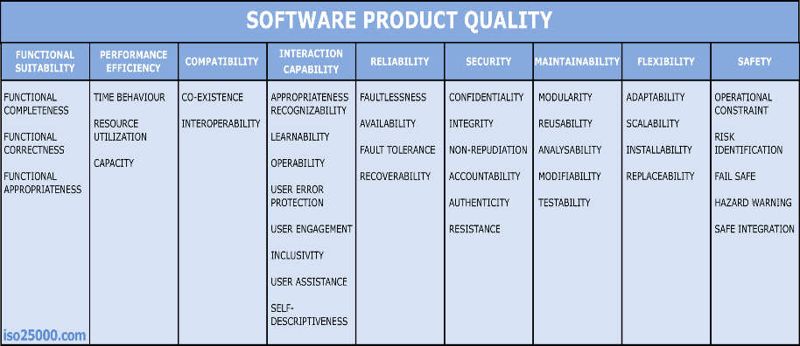
Figure 9 Software Product Quality (ISO 25010)

Functional Suitability - Functional suitability refers to the degree to which the software provides features that meet user requirements. In the context of S-MAN, the software must effectively fulfill the needs of its three main user groups: students, group leaders, and professors. Features such as task assignment, progress tracking, deadline management, and grading capabilities are essential. For example, the Student Group Member Dashboard allows members to view tasks, deadlines, and progress, while the Student Group Leader Dashboard enables leaders to assign tasks, monitor contributions, and make decisions about final grades. The system must ensure that these functionalities are clear, relevant, and comprehensive for its intended users.
Performance Efficiency - This characteristic focuses on how well the software performs under varying conditions, such as load, speed, and resource usage. For S-MAN, performance efficiency means ensuring that the system can handle multiple users, frequent updates (e.g., task progress), and large volumes of data (e.g., member contributions and task history) without slowing down. Real-time updates for notifications, task progress, and feedback are crucial for a smooth user experience. The software should also efficiently handle large class sizes or groups of students and scale accordingly without affecting response times or system stability.
Compatibility - Compatibility is about the software’s ability to operate across various environments, devices, and systems. S-MAN must be compatible with different operating systems (e.g., Windows, macOS, Linux) and support a wide range of web browsers (e.g., Chrome, Firefox, Safari). Additionally, the system needs to integrate smoothly with other institutional software, such as student information systems or learning management systems (LMS), ensuring that professors, group leaders, and students can access it without compatibility issues. The flexibility of the platform, allowing users to access it from any device (smartphones, laptops, tablets), is also a key part of compatibility.
Usability - Usability refers to how easy and intuitive it is for users to interact with the software. For S-MAN, this means that the interfaces for the Student Group Member Dashboard, Student Group Leader Dashboard, and Professor Dashboard must be user-friendly and easy to navigate. Task assignment, progress tracking, and grade management should be straightforward. Clear navigation, helpful tooltips, and a consistent design are important to ensure that users don’t struggle to perform necessary tasks. Given the diverse user base (students, professors, and group leaders), S-MAN needs to be designed to accommodate various levels of tech literacy, ensuring accessibility and minimal training required.
Reliability - Reliability refers to the system’s ability to consistently perform without failure over time. For S-MAN, this means that the platform must be stable and available whenever users need it. This includes ensuring data integrity, where task statuses, deadlines, and grades remain accurate and up-to-date, even under heavy use. Reliability also involves handling potential issues such as server downtime, software bugs, and network interruptions without significant impact on the user experience. To maintain reliability, S-MAN should include mechanisms like automatic backups, robust error handling, and redundancy strategies to prevent data loss.
Security - Security is essential for protecting sensitive information within the software. Since S-MAN involves personal data (students’ academic records, task contributions, grades, etc.), security must be a top priority. This involves implementing secure authentication protocols (e.g., multi-factor authentication, strong password policies) to ensure only authorized users can access their respective dashboards. Data encryption should be used for sensitive communications between the client and server. Additionally, secure role-based access controls must ensure that only group leaders and professors have the ability to modify grades or access confidential information. Regular security updates and vulnerability assessments should also be part of the ongoing development process.
Maintainability - Maintainability refers to how easily the software can be modified to correct defects, improve performance, or adapt to new requirements. For S-MAN, this means the system’s code should be clean, modular, and well-documented so that developers can quickly identify and fix issues or make updates as needed. As the system evolves—such as adding new features or supporting more complex tasks (e.g., AI-based progress tracking)—the codebase should be easy to scale and extend. Regular software maintenance ensures the system remains effective as educational requirements change and technology advances. A well-maintained system also reduces the risk of errors and improves the user experience.
Portability - Portability measures how easily software can be transferred to different environments or adapted to new platforms. For S-MAN, portability means that the system should not be tied to a single platform or deployment method. It should be deployable in various hosting environments (e.g., cloud services like AWS, on-premise servers) and be flexible enough to accommodate different institutional needs. This also includes the ability to integrate with various third-party tools (e.g., external grading systems, communication platforms). Additionally, as educational institutions might require customizations or support for different languages, S-MAN should be able to adapt to these varied use cases without major redevelopment efforts.

Bibliography

Abance, L. B., Gabrillo, J., & Quinto, J. B. (2023). Online Collaborative Learning: the good, the bad, and the purported in thesis writing. Asia Social Issues, 16(5), e262187. https://doi.org/10.48048/asi.2023.262187
Bronke, C. A. (2023). Standards-Based Grading in Traditional-Grading Contexts: A Case study in Asynchronous Professional Development. Huskie Commons. https://huskiecommons.lib.niu.edu/allgraduate-disspractice/2/
Butler, M. (2025). Alternative grading systems and student outcomes: a comparative analysis of motivation, enjoyment, engagement, stress, and perceptions of final grades. Assessment & Evaluation in Higher Education, 1–11. https://doi.org/10.1080/02602938.2025.2475068
Carr, S. E., Wilson, T. E., Slone, S. A., Karanja, L. W., & Osterhage, J. L. (2024). Assigned group work is associated with increased student motivation and perceptions of belonging in an asynchronous online physiology laboratory course. AJP Advances in Physiology Education, 48(3), 593–602. https://doi.org/10.1152/advan.00064.2024
Chapkovski, P. (2020). Strike one hundred to educate one: Can collective sanctions be efficient? SSRN Electronic Journal. https://doi.org/10.2139/ssrn.3728838
Deysolong, J. (2023). Investigating the effects of homework on student learning and academic performance. Figshare. https://doi.org/10.6084/m9.figshare.23002418.v3
Dulinayan, R. M. P., Mariano, J. I. T., Abella, M. G. J., Layugan, J. N. V., & Israel, K. a. L. (2023). Understanding group cohesion and teamwork among college students in online learning. Zenodo (CERN European Organization for Nuclear Research). https://doi.org/10.5281/zenodo.8217646
Dugang, M. a. P. (2020). School teamwork and effectiveness. https://al-kindipublisher.com/index.php/jweep/article/view/1601
Fagbohun, O., Iduwe, N. P., Abdullahi, M., Ifaturoti, A., & Nwanna, O. M. (2024). Beyond traditional assessment: Exploring the impact of large language models on grading practices. Journal of Artificial Intelligence Machine Learning and Data Science, 2(1), 1–8. https://doi.org/10.51219/jaimld/oluwole-fagbohun/19

Fragata, L. D. D., & Limpot, M. Y. (2023). Peer pressure and motivation of student learning in Filipino: The Mediating effect of Cooperative learning. Asian Journal of Education and Social Studies, 44(1), 1–12. https://doi.org/10.9734/ajess/2023/v44i1951
Garrison, D. R., Anderson, T., & Archer, W. (2001). Critical thinking, cognitive presence, and computer conferencing in distance education. American Journal of Distance Education, 15(1), 7–23. https://doi.org/10.1080/08923640109527071
Gonzales, G. H. A., Despe, K. B., Iway, L. J., Genon, R. J. S., Intano, J. O., & Sanchez, J. M. P. (2023). Online Collaborative learning platforms in Science: their influence on attitude, achievement, and experiences. Journal of Educational Technology and Instruction., 2(2), 1–16. https://doi.org/10.70290/jeti.v2i2.55
Liu, C., Yang, C., & Chao, P. (2019). A longitudinal analysis of student participation in a digital collaborative storytelling activity. Educational Technology Research and Development, 67(4), 907–929. https://doi.org/10.1007/s11423-019-09666-3
Morgan, S. E., Ahn, S., Mosser, A., Harrison, T. R., Wang, J., Ryan, A., Mao, B., & Bixby, J. L. (2021). The effect of team communication behaviors and processes on interdisciplinary teams’ research productivity and team satisfaction. https://www.informingscience.org/Publications/4857
Rogayan, D. V., Jr, Rafanan, R. J. L., & De Guzman, C. Y. (2021). Challenges in STEM learning: a case of Filipino high school students. Jurnal Penelitian Dan Pembelajaran IPA, 7(2), 232. https://doi.org/10.30870/jppi.v7i2.11293
Workumuluye, W. M., & Tadesse, S. (2020). Improving student participation in group project work: case study. https://ijer.inased.org/makale/1661
Sanders, E. (2021). Gradeless learning: The effect of eliminating traditional grading practices on student engagement and learning. RED: A Repository of Digital Collections. https://red.mnstate.edu/thesis/527/
Terenzini, P. T., Cabrera, A. F., Colbeck, C. L., Parente, J. M., & Bjorklund, S. A. (2001). Collaborative Learning vs. Lecture/Discussion: Students’ Reported Learning Gains*. Journal of Engineering Education, 90(1), 123–130. https://doi.org/10.1002/j.2168-9830.2001.tb00579.x

Viado, A. L., & Department, J. a. E. (2023). The Collaborative-Individual Learning in improving the critical thinking skills of secondary students in the Philippines. International Journal of Multidisciplinary Applied Business and Education Research, 4(7), 2592–2600. https://doi.org/10.11594/ijmaber.04.07.35
Pardo-Tolentino, C. F., & Aggabao, R. G. (2020). Collaborative Instructional Strategies and Attitudes toward Second Language Learning. International Journal of Linguistics Literature & Translation, 3(5), 60–67. https://doi.org/10.32996/ijllt.2020.3.5.7
Villanueva, J. a. R., Redmond, P., Galligan, L., & Eacersall, D. (2023). Investigating blended learning interactions in Philippine schools through the community of inquiry framework. Asia Pacific Education Review. https://doi.org/10.1007/s12564-023-09826-4
Xu, B., Stephens, J. M., & Lee, K. (2023). Assessing Student Engagement in Collaborative Learning: Development and validation of new measure in China. The Asia-Pacific Education Researcher, 33(2), 395–405. https://doi.org/10.1007/s40299-023-00737-x

Appendixes

APPENDIX A
Work Breakdown Structure

Major Activities | Minor Activities | Duration (week) | Stakeholder
A. Requirements | Define Project Scope | 2 | Soriano
A. Requirements | Identify User Roles (Students, Leaders, Professors) | 1 | All Members
A. Requirements | Gather Functional Requirements | 2 | All Members
A. Requirements | Documentation | 1 | Prestoza
B. Planning
 | Research on Task Tracking Methods | 2 | Bumagat
 | Define System Features & UI Design | 2 | Soriano
 | IIdentify Tech Stack (Firebase, React, etc.) | 2 | Soriano, Prestoza
 | Documentation | 1 | Prestoza
C. Design
 | Design System Architecture | 2 | Soriano
 | Create UI/UX Wireframes  Prototyping | 2  4 | Bumagat, Prestoza  Soriano, Prestoza
 | Documentation | 1 | Prestoza
D. System Development
 | Develop Frontend Interface (Student & Leader Dashboards) | 2 | Soriano
 | Integrate Task Assignment & Tracking System | 2 | Soriano, Bumagat
 | Implement Professor Dashboard & Grade Management | 2 | Soriano, Bumagat
 | Implement Authentication & User Roles | 1 | Soriano
 | Documentation | 1 | Prestoza
E. Testing
 | Unit Testing (Dashboard, Notifications, etc.) | 2 | All Members
 | User Testing with Sample Students/Professors | 2 | Selected Users
F. Deployment
 | Deploy System on Test Server | 1 | All Members
 | Final Deployment & Optimization | 2 | All Members
G. Maintenances
 | Bug Fixes & Updates | Ongoing | All Members
 | User Feedback & Feature Enhancements | Ongoing | All Members

APPENDIX B
Gantt Chart

ACTIVITIES | MARCH |  |  |  | APRIL |  |  |  | MAY |  |  |  | JUNE |  |  |  | JULY
ACTIVITIES | 1 | 2 | 3 | 4 | 1 | 2 | 3 | 4 | 1 | 2 | 3 | 4 | 1 | 2 | 3 | 4 | 1 | 2 | 3 | 4
A. Requirements
Define Project Scope
Identify User Roles & Functional Needs
Gather Functional Requirements
B. Planning
Research on Task Tracking Methods
Define System Features & UI Design
Identify Tech Stack (Firebase, React, etc.)
C. Design
Design System Architecture
Create UI/UX Wireframes
Prototyping
D. System Development
Develop Frontend Interface
Integrate Task Assignment & Tracking System
Implement Professor Dashboard & Grade Management

ACTIVITIES | AUGUST |  |  |  | SEPTEMBER |  |  |  | OCTOBER |  |  |  | NOVEMBER |  |  |  | DECEMBER
ACTIVITIES | 1 | 2 | 3 | 4 | 1 | 2 | 3 | 4 | 1 | 2 | 3 | 4 | 1 | 2 | 3 | 4 | 1 | 2 | 3 | 4
Implement Authentication & User Roles
E. Testing
Unit Testing
User Testing with Sample Students/Professors
F. Deployment
Deploy System on Test Server
Final Deployment & Optimization
G. Maintenance
Bug Fixes & Updates
User Feedback & Feature Enhancements
H. Documentation

APPENDIX C
Budgetary Allowance

Professional Fee:
 | Hosting  Domain Name Registration | ₱ 4000  ₱ 1500
Others:
 | Photocopy | ₱6000
 | Meal | ₱3000
 | Total Budget | ₱14, 500

Researcher’s Profile


Marshalle Nopi B. Soriano
Address: BLK 19 LOT 25, Golden Hills Panorama Subdivision, Loma De Gato, Marilao City Bulacan
Contact No: 09275159359
Email: lmnnooopi@gmail.com
Motivated software developer and systems designer with strong academic experience in business applications and collaborative platforms. Experienced in developing academic accountability systems using Firebase, Java, and Python. Passionate about creating structured delegation tools that enhance group project transparency and efficiency.

Educational Attainment
(2022 - Present) | Our Lady of Fatima University - Valenzuela Campus  Bachelor of Science in Information and Technology
(2020 - 2022) | Our Lady of Fatima University - Valenzuela Campus  STEM - Senior High School
(2016 - 2020) | Saint Mary’s Academy of Sto Niño.  High School
(2009 - 2016) | Saint Anne and the Blessed Mary Academy.  Elementary

Technical Skills
SKILLS | PROFICIENCY LEVEL
Languages: Python, Firebase, Java, C++, Ruby, HTML/CSS | Skilled
Applications: Git, Figma, Adobe Suite | Intermediate
Computer Hardware: PC Troubleshooting, Technical Support | Intermediate

Ivy Bilan Bumagat
Address: 9153 Pateros St. Brgy Valenzuela Makati City
Contact No: 09283510620

Passionate and detail-oriented software developer with strong foundations in Java, Python, and web technologies. Seeking to join a forward-thinking development team where I can contribute to innovative projects and continue learning new technologies.

Educational Attainment
(2022 - Present) | Our Lady of Fatima University - Valenzuela Campus  Bachelor of Science in Information and Technology
(2020 - 2022) | Gen. Pio del Pilar National High School  ABM - Senior High School
(2013 - 2020) | Gen. Pio del Pilar National High School  High School
(2007 - 2013) | Nicanor Garcia Elementary School  Elementary

Technical Skills
SKILLS | PROFICIENCY LEVEL
Languages: Python, , Java, C++, HTML/CSS | Intermediate
Applications: Canva, Microsoft Suite, Adobe Suite | Intermediate
Computer Hardware: PC Troubleshooting, Technical Support | Intermediate



Shaina Mae C. Prestoza
Address: 62-A Karuhatan Valenzuela City
Contact No: 09163017591
Email: shainaprestoza8@gmail.com
Creative and detail-oriented web developer with a strong foundation in HTML, CSS, JavaScript, and UI/UX principles. Passionate about crafting visually engaging, responsive, and user-friendly websites. Seeking to join an innovative team where I can contribute to impactful design projects and continue growing my expertise in modern web design tools and frameworks.

Educational Attainment
(2022 - Present) | Our Lady of Fatima University - Valenzuela Campus  Bachelor of Science in Information and Technology
(2020 - 2022) | Bayambang National High School - Senior High School  HUMSS - Senior High School
(2016 - 2020) | Bayambang National High School  High School
(2010 - 2016) | Paragos Elementary School  Elementary

Technical Skills
SKILLS | PROFICIENCY LEVEL
Languages: Python, Java, SQL, HTML/CSS | Skilled
Applications: Canva, Figma, Visual Studio Code | Skilled

